**SQL WORKSHEET**

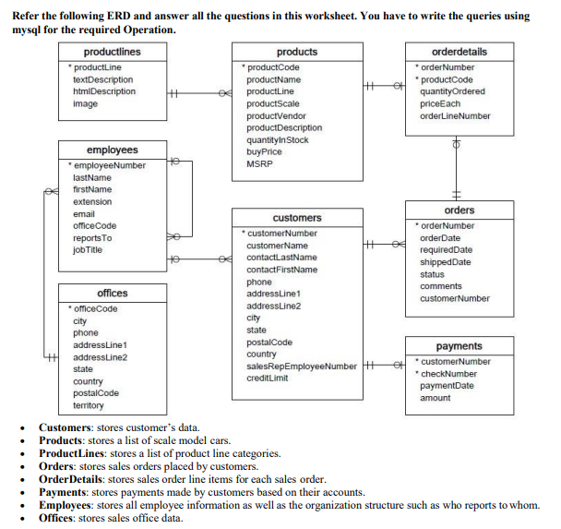

The basic steps to initiate a sqlite3 are as follows

# To connect to import sqlite3

Code : import sqlite3

# To connect to the database

Code : db=sqlite3.connect("customersdata.db")

# To give a variable for the cursor

Code : cur=db.cursor()

1. **Write SQL query to create table Customers.**

Code:

cur.execute("create table Customers (customerNumber int primary key, CustomerName varchar(30), ContactLastName varchar(20), ContactFirstName varchar(20), phone int, addressLine1 varchar(20), addressLine2 varchar(20), city varchar(20), state varchar(20), postalCode int, country varchar(20), salesRepEmployeeNumber int, creditLimit float);")

1. **Write SQL query to create table Orders.**

Code:

cur.execute("create table Orders(orderNumber int primary key, orderDate int, requiredDate int, shippedDate int, status varchar(20), comments varchar(30), customerNumber int);")

1. **Write SQL query to show all the columns data from the Orders Table.**

Code:

cur.execute("select * from Orders;")

1. **Write SQL query to show all the comments from the Orders Table.**

Code:

cur.execute(" select comments from Orders;")

1. **Write a SQL query to show orderDate and Total number of orders placed on that date, from Orders table.**

Code:

cur.execute(" select orderDate, count(orderNumber) from orders group by orderDate;")

1. **Write a SQL query to show employeNumber, lastName, firstName of all the employees from employees table.**

Code:

cur.execute ("create table employees (employeeNumber int primary key, lastName varchar(20), firstName varchar(20), extension varchar(20), email varchar(30), OfficeCode varchar(10), reportsTo varchar(30), jobTitle varchar(30));")

cur.execute("select employeeNumber, lastName,firstName from employees;")

1. **Write a SQL query to show all orderNumber, customerName of the person who placed the respective order.**

Code:

cur.execute("select Orders.orderNumber, Customers.CustomerName from Customers INNER JOIN Orders ON Orders.customerNumber=Customers.customerNumber;")

1. **Write a SQL query to show name of all the customers in one column and salerepemployee name in another column.**

Code:

cur.execute(" select customerName, salesRepEmployeeNumber from Customers;")

1. **Write a SQL query to show Date in one column and total payment amount of the payments made on that date from the payments table.**

Code:

cur.execute("create table payments (customerNumber int NOT NULL primary key, checkNumber int, paymentDate DATE, amount int);")

cur.execute("select date(paymentdate), sum(amount) as total from payments group by date(paymentdate);")

1. **Write a SQL query to show all the products productName, MSRP, productDescription from the products table.**

Code:

cur.execute("create table products (productCode int primary key, productName varchar(20), productLine varchar(20), productScale varchar(20), productVendor varchar(20), productDescription varchar(20), quantityInStock int, buyPrice int, MSRP int);")

cur.execute("select productName, MSRP, productDescription from products;")

1. **Write a SQL query to print the productName, productDescription of the most ordered product.**

Code:

cur.execute("select productName, productDescription from products group by productName order by count(productName) desc limit 1;")

1. **Write a SQL query to print the city name where maximum number of orders were placed.**

Code:

cur.execute("select city from Customers inner join orders on Customers.customerNumber=Orders.customerNumber group by city order by city desc limit 1;")

1. **Write a SQL query to get the name of the state having maximum number of customers.**

Code:

cur.execute("select state from customers group by state order by count(customerNumber) desc limit 1;")

1. **Write a SQL query to print the employee number in one column and Full name of the employee in the second column for all the employees.**

Code:

cur.execute("select employeeNumber from employees;")

cur.execute("select (firstName || '' || lastName) as fullname from employees order by fullname;")

1. **Write a SQL query to print the orderNumber, customer Name and total amount paid by the customer for that order (quantityOrdered × priceEach).**

Code:

cur.execute("create table orderdetails (orderNumber int NOT NULL primary key, productCode int, quantityOrdered int, priceEach int, orderLineNumber int);")

cur.execute("select orders.orderNumber, Customers.customerName, orderdetails.quantityOrdered, orderdetails.quantityOrdered*orderdetails.priceEach as totalamount from ((orders inner join Customers on orders.customerNumber=Customers.customerNumber) inner join orderdetails on orders.orderNumber=orderdetails.orderNumber)")